UNIVERSITY OF SCIENCE - VNUHCM
FACULTY OF INFORMATION TECHNOLOGY

OBJECT-ORIENTED PROGRAMMING REPORT
SUBJECT: MANAGEMENT SYSTEM APPLICATION

Instructor:
Võ Nhật Tân
Trương Tấn Khoa
Students:
Huỳnh Phúc Nguyên
Đỗ Minh Khang
Nguyễn Viết Bách
Lâm Hồng Hải Hoàng Lê
Dương Anh Hào

ACKNOWLEDGEMENTS

GROUP INTRODUCTION

General information

Group ID: 01
Student ID | Full Name | Email
25127106 | Huỳnh Phúc Nguyên | hpnguyen2527@clc.fitus.edu.vn
25127045 | Dương Anh Hào | dahao2532@clc.fitus.edu.vn
25127207 | Lâm Hồng Hải Hoàng Lê | lhhhle2508@clc.fitus.edu.vn
25127275 | Nguyễn Viết Bách | nvbach2517@clc.fitus.edu.vn
25127363 | Đỗ Minh Khang | dmkhang2525@clc.fitus.edu.vn

Member roles and task assignments

Full Name | Assigned Tasks | Contribution (%)
Huỳnh Phúc Nguyên
Dương Anh Hào
Lâm Hồng Hải Hoàng Lê
Nguyễn Viết Bách
Đỗ Minh Khang

PROBLEM STATEMENT

Selected management topic
A Warehouse Management System (WMS) has been selected as the core topic for this project to simulate and solve common inventory tracking challenges through an object-oriented approach. In traditional manual systems, reliance on paper records or simple spreadsheets often leads to frequent data discrepancies, delayed updates during stock intake, and general inefficiencies. For an academic programming project, this domain provides a highly practical environment to demonstrate four Object-Oriented Programming (OOP) concepts: Encapsulation, Inheritance, Polymorphism, and Abstraction. Furthermore, to ensure the software architecture is scalable and follows clean coding standards, the system will integrate at least two design patterns, specifically the ... Pattern and the ... Pattern, which will decouple object creation and behavioral interactions within the system.

Target Users
The system categorizes target users into three main operational roles to establish basic access control and reflect a standard warehouse environment.
- Inventory Managers oversee the general state of the warehouse by monitoring stock levels, approving inbound or outbound requests, defining safety thresholds for reordering, and viewing system reports.
- Warehouse Staff handle day-to-day operations on the floor, interacting directly with the program to perform physical stocktakes, update item storage locations, and log new stock movements.

Main features
The main features of the application are divided into core functional modules that cover the fundamental workflows of warehouse management.
- Product and Inventory Management handles essential CRUD (Create, Read, Update, Delete) operations, allowing users to maintain accurate digital profiles of items, track quantities, and record storage locations.
- Inbound Management simplifies the receiving process by logging incoming items from suppliers, verifying quantities against purchase records, and generating receipt notes to update the system's inventory.
- Outbound Management manages the shipping process by processing order requests, creating picking lists for staff, reducing the available stock counts, and issuing outbound delivery notes.

Input and output data

SYSTEM DESIGN
  - UML Class Diagram
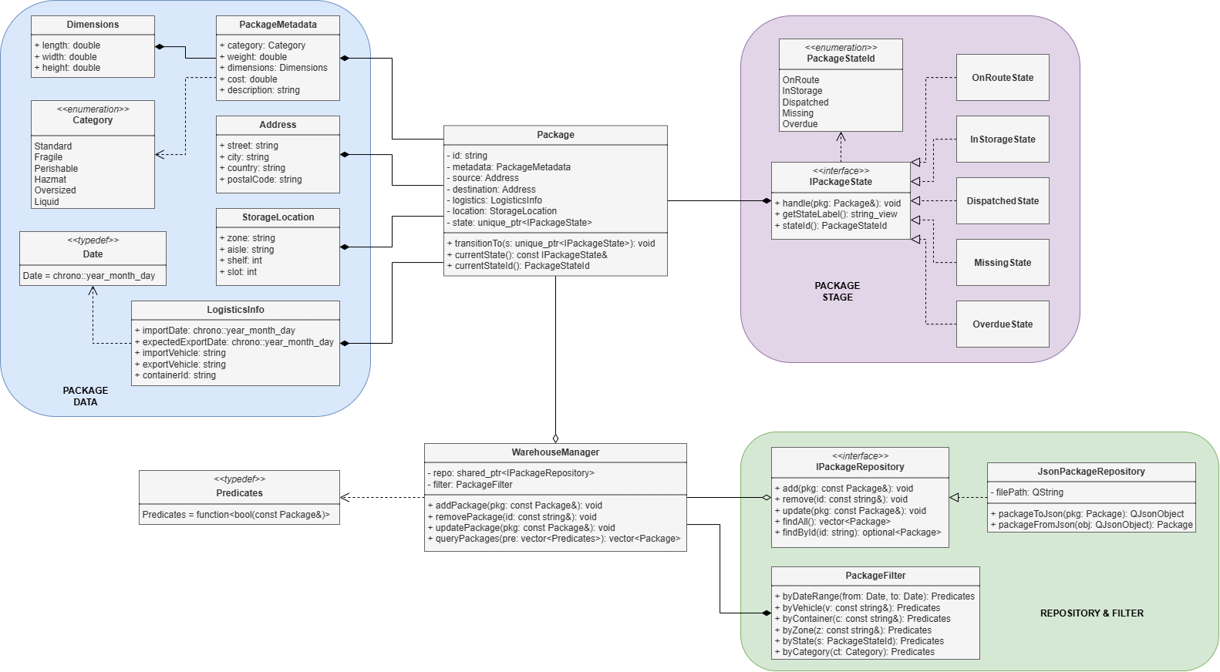
Image 3.1.1. UML Warehouse management system

  - Main classes and relationships
The UML diagram describes a Warehouse Management System built around object-oriented design principles. The system is organized into three cohesive groups:
- Package Data: The core main model
- Package Stage: The state machine governing a package's lifecycle
- Repository & Filter: The persistence and query layer

    - Package Data Group
This group contains all classes needed to fully describe a package stored in the warehouse.
      - Package - Central Domain Class
- Package: sits at the heart of the system. Every other class in the domain model either belongs to a package or provides a service that operates on one.
- Fields:
- id: string — Unique identifier for the package.
- metadata: PackageMetadata — Descriptive properties such as category, weight, dimensions, cost, and a free-text description.
- source: Address — The origin address.
- destination: Address — The delivery address.
- logistics: LogisticsInfo — Import/export dates, vehicle details, and the container ID assigned to the shipment.
- location: StorageLocation — Physical position inside the warehouse (zone, aisle, shelf, slot).
- state: unique_ptr<IPackageState> — A polymorphic handle to the package's current state object, enabling the State Pattern.
- Methods:
- transitionTo(s: unique_ptr<IPackageState>): void — Replaces the current state with a new one, triggering any entry logic defined by that state.
- currentState(): const IPackageState& — Returns a read-only reference to the active state.
- currentStateId(): PackageStateId — Returns the corresponding enum value for quick branching without a dynamic cast.

      - PackageMetadata
A value object that groups the descriptive attributes of a package. It does not carry an identity of its own; its meaning comes entirely from being part of a Package.

Field | Type | Purpose
category | Category (enum) | Classifies the package (Standard, Fragile, Perishable, Hazmat, Oversized, Liquid)
weight | double | Weight in kilograms
dimensions | Dimensions | Three-dimensional size — composed of a Dimensions object
cost | double | Declared monetary value of the shipment
description | string | Free-text description for additional detail

      - Address
A simple value object that holds a postal address. Because Package contains two instances — source and destination — the class is reused rather than duplicated, following the DRY principle.
- street, city, country, postalCode: string — Standard address fields.
      - StorageLocation
Encodes the exact physical slot where a package rests inside the warehouse. The four-level hierarchy (zone → aisle → shelf → slot) makes it straightforward to map the model to real warehouse infrastructure.
- zone: string — Broad area of the warehouse
- aisle: string — Row within the zone.
- shelf: int — Vertical level on the rack.
- slot: int — Individual position on the shelf.

      - LogisticsInfo
Captures the logistics timeline and transportation details for a shipment. Dates are typed as chrono::year_month_day — aliased throughout the project as Date via a typedef defined in the companion Date node in the diagram.
- importDate, expectedExportDate: Date — When the package arrived and when it is due to leave.
- importVehicle, exportVehicle: string — Vehicle identifiers used for inbound and outbound transport.
- containerId: string — The container assigned to carry this package.

      - Dimensions
A minimal value object representing the physical size of a package. It is composed into PackageMetadata rather than embedded directly in Package, keeping measurement concerns separate from identification and logistics concerns.
- length, width, height: double — All three dimensions in a consistent unit (e.g., centimetres).
      - Enum Category
An enumeration that constrains the type of goods a package may contain. The six values cover the most common warehouse handling categories:
- Standard — General-purpose goods with no special handling requirements.
- Fragile — Items susceptible to breakage; require cushioned storage.
- Perishable — Time-sensitive goods that may need refrigeration.
- Hazmat — Hazardous materials subject to safety regulations.
- Oversized — Packages that exceed standard size thresholds.
- Liquid — Fluid cargo that requires leak-proof containment.

      - Typedef Date
A type alias — Date = chrono::year_month_day — that gives a concise, domain-friendly name to the standard-library date type. It is referenced by LogisticsInfo and by PackageFilter's byDateRange method.
    - Package Stage Group
This group implements the State Pattern. Rather than scattering conditionals like if (state == OnRoute) { ... } across the codebase, each lifecycle phase is encapsulated in its own class. The package delegates all state-dependent behaviour to its current state object.
      - Interface IPackageState
The contract that every concrete state must fulfill. Depending on Package through the handle() method creates a bidirectional relationship: the interface knows about Package, and Package holds an IPackageState — a classic State Pattern collaboration.
- handle(pkg: Package&): void — Called to evaluate whether the package should transition to a different state. Each concrete class decides independently.
- getStateLabel(): string_view — Returns a human-readable label suitable for UI display or logging.
- stateId(): PackageStateId — Returns the enum value that identifies this state, enabling efficient comparisons without dynamic type inspection.

      - Enum PackageStateId
Lists every valid state in the lifecycle. Keeping this as an enum — rather than comparing class types — makes serialization, filtering, and switch-based dispatch straightforward.
Enum Value | Concrete Class | Meaning
OnRoute | OnRouteState | Package is in transit between locations
InStorage | InStorageState | Package has arrived and is held in the warehouse
Dispatched | DispatchedState | Package has been delivered or collected by the recipient
Missing | MissingState | Package cannot be located and requires investigation
Overdue | OverdueState | Package has passed its expected export date without being dispatched

      - Concrete State Classes
Each class encapsulates the rules and transitions that apply in one particular phase of the package lifecycle:
- OnRouteState — Active while the package is travelling to the warehouse. On arrival, handle() calls pkg.transitionTo(new InStorageState).
- InStorageState — Active once the package is shelved. handle() checks whether the expected export date has passed (→ OverdueState) or whether a dispatch event has been recorded (→ DispatchedState).
- DispatchedState — Terminal state indicating successful delivery. No further automatic transitions occur.
- MissingState — Activated when a stock check fails to locate the package. Investigation and manual resolution are required before any further transition.
- OverdueState — Activated when a package remains in storage beyond its expectedExportDate. Typically triggers an alert or escalation workflow.
    - Repository and Filter Group
This group separates the domain model from storage concerns and provides a flexible query mechanism, following the Repository Pattern and the Open/Closed Principle.
      - Interface IPackageRepository
Defines the five operations that any storage backend must support. By programming to this interface, WarehouseManager remains completely decoupled from the underlying storage technology — swapping JSON files for a database requires no changes to business logic.
- add(pkg: const Package&): void — Persists a new package.
- remove(id: const string&): void — Deletes a package by its identifier.
- update(pkg: const Package&): void — Overwrites the stored record with an updated version.
- findAll(): vector<Package> — Retrieves every package; used as the starting set for filtered queries.
- findById(id: string): optional<Package> — Returns a single package, or an empty optional if the ID is not found.
      - JsonPackageRepository
JsonPackageRepository is the concrete implementation that reads and writes packages to a JSON file using the Qt framework. Two conversion helpers keep serialization logic contained and reusable:
- packageToJson(pkg: Package): QJsonObject — Serializes all fields of a package into a JSON object.
- packageFromJson(obj: QJsonObject): Package — Deserializes a JSON object back into a fully populated Package instance.
- filePath: QString — The path to the JSON file that serves as the data store.

      - PackageFilter
A utility class that produces Predicates — small, single-purpose filter functions — rather than performing filtering itself. This design lets callers compose multiple criteria freely and pass them as a collection to WarehouseManager.
- byDateRange(from, to: Date): Predicates — Keeps packages whose import date falls within the given window.
- byVehicle(v: string): Predicates — Matches packages tied to a specific import or export vehicle.
- byContainer(c: string): Predicates — Matches packages assigned to a given container.
- byZone(z: string): Predicates — Matches packages stored in a particular zone.
- byState(s: PackageStateId): Predicates — Matches packages currently in the specified state.
- byCategory(ct: Category): Predicates — Matches packages of the given goods category.
Typedef Predicates: Predicates = function<bool(const Package&)> — A standard-library function object that takes a const reference to a package and returns true if that package should be included in the result set.
      - WarehouseManager
WarehouseManager is the main entry point for all business operations. It bridges the domain layer and the persistence layer, and owns a PackageFilter instance for building queries.
Fields:
- repo: shared_ptr<IPackageRepository> — A shared pointer to the repository. Injected at construction time, so the concrete type (e.g., JsonPackageRepository) can be substituted without modifying this class.
- filter: PackageFilter — The filter factory, composed directly into the manager.
Methods:
- addPackage(pkg: const Package&): void — Delegates to repo.add()
- removePackage(id: const string&): void — Delegates to repo.remove()
- updatePackage(pkg: const Package&): void — Delegates to repo.update()
- queryPackages(pre: vector<Predicates>): vector<Package> — Retrieves all packages from the repository and returns only those satisfying every predicate in the list. Multiple filters are applied conjunctively (logical AND).

    - Relationship Summary

From | To | Relationship | Notes
Package | PackageMetadata | Composition ◆ | Package owns metadata; metadata cannot exist alone
Package | Address (× 2) | Composition ◆ | Owns both source and destination addresses
Package | StorageLocation | Composition ◆ | Owns the physical storage coordinates
Package | LogisticsInfo | Composition ◆ | Owns the logistics and timeline data
Package | IPackageState | Composition ◆ | Holds the current state via unique_ptr
PackageMetadata | Dimensions | Composition ◆ | Owns the size value object
PackageMetadata | Category | Dependency → | Uses the Category enum
LogisticsInfo | Date | Dependency → | Uses the Date typedef for date fields
IPackageState | PackageStateId | Dependency → | Returns PackageStateId from stateId()
*State classes | IPackageState | Realization --|> | All five concrete states implement the interface
WarehouseManager | IPackageRepository | Aggregation ◇ | Holds a shared_ptr; lifetime not solely controlled here
WarehouseManager | PackageFilter | Composition ◆ | Owns the filter factory by value
WarehouseManager | Predicates | Dependency → | Accepts and applies predicate collections
JsonPackageRepository | IPackageRepository | Realization --|> | Provides the JSON-backed implementation

  - Application flow or main use-case flow.
  - Project structure.

PROJECT ARCHITECTURE

IMPLEMENTATION AND TESTING

AI USAGE AND INDIVIDUAL ACCOUNTABILITY

CHALLENGES AND FUTURE ENHANCEMENTS

REFERENCES

APPENDICES

